**Report on Analysis of Game Feedback Dataset**

**Author: Rohit Khilare**

**Introduction:**

This report presents an analysis of feedback gathered from participants at various universities regarding a game designed to educate about the acquisition process. The dataset contains responses to specific questions about the game experience, including its educational value, clarity of rules, and overall enjoyment.

**Dataset Overview:**

* The dataset includes responses from multiple universities.
* Each response includes ratings and comments on different aspects of the game.

Question 1: What are Number of students for various universities were participating?

Question 2: Playing the game raised my awareness about the acquisition process?

*The bars for University A, University B, and University C are all above 50%, which means that most students from these universities agreed with the statement. The bar for University D is below 50%, but it is still close to the middle of the scale. This suggests that while most students from University D did not strongly agree with the statement, they also did not disagree with it.*

Question 3: On a scale of 1 – 5, how curious are you to learn more about the terms related to the acquisition process?

*The bars for all four universities are clustered around the "3" and "4" options, suggesting that most students were somewhat or very curious to learn more.*

Question 4: Does playing the game helped me understand my communication style?

*Yes, according to the pie chart, playing the game did help understanding the communication style. The pie chart shows that 35.9% of respondents (14 people) said that playing the game helped them understand their communication style "a lot," while 23.08% (9 people) said it helped them "somewhat" and another 23.08% (9 people) said it helped them "a little." Only 17.95% (7 people) said that playing the game did not help them understand their communication style at all.*

*Overall, 82.14% of respondents said that playing the game helped them understand their communication style in some way, suggesting that the game was effective in this regard.*

Question 5: Does playing the game helped me discover my competitive spirit?

*The bars for University A, University B, and University C are all above 50%, which means that many students from these universities agreed with the statement. The bar for University D is below 50%, but it is still close to the middle of the scale. This suggests that while many students from University D did not strongly agree with the statement, they also did not disagree with it.*

*Overall, the image suggests that playing the game had a positive impact on students' discovery of their competitive spirit.*

Question 6: Does playing the game helped me increased awareness of my personal values?

*The bars for all four universities are above 50%, which means that many students from these universities agreed with the statement. The percentage of students who agreed with the statement ranges from 57.14% (University B) to 71.43% (University A), suggesting that a significant majority of students found the game to be helpful in increasing their awareness of their personal values.*

*Overall, the Graph suggests that playing the game had a positive impact on students' awareness of their personal values.*

Question 7: What are some of things you did not like about the game? Please be as specific as possible.

We performed sentiment analysis on the responses for all university scholars and thus we got,

*From this graph we can say that the University A has a lot of positive responses and University B, and D had a lot of negative response.*

*Also, that the University C has some Neutral opinion as well.*

*We also generated a Word cloud for overall responses across all universities and thus we got:*

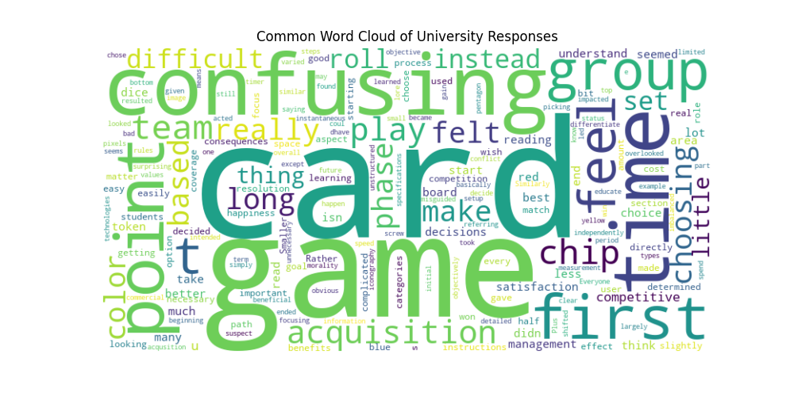

*From which we can say that a lot of responses are pointing towards the Confusing genre of the card game.*

Question 8: Were the rules of the game confusing?

*Based on the pie chart, it appears that most students found the rules of the game confusing. The image shows a pie chart with the following information:*

*17.95% of students said the rules were "not confusing at all”.*

*23.08% said they were "a little confusing”.*

*23.08% said they were "somewhat confusing”.*

*35.9% said they were "very confusing”.*

*Therefore, 79% of students found the rules to be at least somewhat confusing.*

Question 9: Please elaborate on the rules you found confusing?

*For those feedback question we used sentiment analysis and found that*

*The graph clearly shows that a lot of feedback from scholars are neutral in nature as a lot of feedback specially from University D and B are also negative in nature.*

*For getting a clear image we had constructed a word cloud to know the feedback responses more clearly.*

*Here a lot of students clearly said that the rules of game was a lot “Confusing” and the fact that the game was technically appreciated by all scholars in terms of knowing technical views of acquisition process.*

*And we had also recorded the amount of feedback per university:*

*Where University A and B had given a lot of feedback.*

Question 10: Overall, the game was an instructive experience?

*Overall, 62.2% of students agreed that the game was an instructive experience. This is calculated by averaging the percentages for each university, which range from 54.55% to 71.43%.*

*University B had the highest percentage of students who agreed with the statement (71.43%).*

*University D had the lowest percentage of students who agreed with the statement (54.55%).*

Conclusion:

The examination of the dataset yields several significant findings pertaining to the experiences of the participants in relation to the system's acquisition process:

In general, the participants reached a consensus that engaging in the game increased their understanding of the acquisition process and stimulated their interest in further exploring associated terminology. Nevertheless, the feedback was inconclusive about whether the game truly assisted participants in comprehending their individual communication styles and identifying their competitive nature.

Several values Indicated a heightened consciousness regarding their personal values; however, the game also elicited significant criticisms and aversions. Frequent concerns encompassed uncertainties regarding setup procedures and rules, an excessive focus on point-scoring at the expense of strategic decision-making, and a dearth of clarity regarding specific game mechanics, such as the appropriate moment to throw the dice.

Additionally, the participants voiced apprehensions regarding the insufficient differentiation between phases or cards, the restricted variety of gameplay options which resulted in repetitiveness, and the game's lack of competitiveness, which was attributed to inadequate consequences for actions.

Participants proposed several enhancements to the game experience: more explicit rules and instructions, a greater diversity of gameplay elements, more distinct distinctions between phases or cards, and heightened levels of competition.

In conclusion, although the game effectively generated inquiry and increased awareness regarding the acquisition process, it would be advantageous to improve its overall efficacy and appeal as an educational aid by resolving the identified concerns and implementing the recommended enhancements.